The Bhopal Library

Today, Dec. 3, 2009, on the 25th anniversary of the Bhopal, India tragic gas disaster, we call to your attention a special collection of books - The Bhopal Library - that reveal the evolving understanding of the meaning of the Bhopal, India tragedy over the last 25 years. The Bhopal Library is an offering of the Apex Press, publishing arm of the Council on International and Public Affairs, whose Publisher Ward Morehouse is a co-founder of the International Coalition for Justice in Bhopal. (He has also co-authored several of these books.)

This collection of books, recording the history of this 25-year-period in real time, offers a unique chronicle of the growing understanding of human rights activists, doctors, lawyers, historians and social scientists, of the enormity of this still-ongoing case. With today’s globalization of multinational corporations, the lessons for the world from the Bhopal case illuminates the need to understand how to make Human Rights a key standard in today’s industrial globalization. These books—including documents and primary sources-- shed light on the growing understanding of the meaning of the Bhopal gas study for a globalized world and offer a special retrospective for the study of Bhopal and/or the study of the coming to consciousness of the impact of globalization.

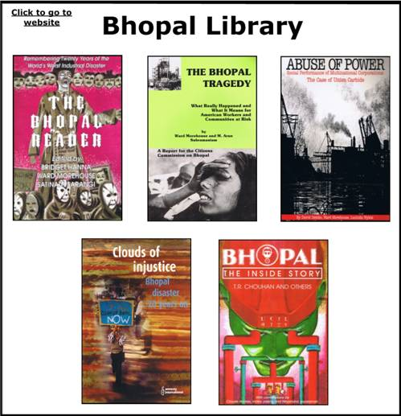

When the first books were written in the early years after the world’s worst industrial disaster (often called India’s “Hiroshima”) the concepts of environmentalism and ecology were being born. As the case continued to meet government and corporate resistance, and books continued to be written - and films to be made - the body of this work together began to take on a whole different understanding of how broad the issues surrounding Bhopal really are.

Today, new victims still continue to suffer a quarter century after the original catastrophe, because the standoff of corporations and governments led to a site full of lethal chemicals sitting for years leeching into the soil, opening up new water aquifers to chemical pollution.

Bhopal is not just a human rights tragedy from the last century. In 2004 Amnesty International reported that Bhopal was the canary in the mine for a world with no governance of multinational corporations.
In its case study, "Clouds of Injustice", Amnesty International’s main conclusion is the need to make Human Rights a key standard in today’s industrial globalization. Others of these books chronicle the growing understanding of that need as supporters of the victims faced innumerable obstacles between state and federal governments in India, in the US courts, and between corporations—Union Carbide, the original owner who refused to clean up the plant site and then Dow Chemical, which purchased the plant and refused to accept responsibility. Its failure to clean up the site to this day has created new victims of polluted water aquifers from the lethal chemicals sitting on the ground leaking into the soil. To date no legal or corporate authority has been able to compel the corporation to make good on these human rights violations.

This Amnesty International report uses the Bhopal case to illustrate corporate evasion of human rights responsibilities and underlines the need to establish a universal human rights framework for business, based on the UN Norms for Business. The report states it is imperative for such standards to be implemented and a mechanism to enforce them be put in place, "to hold companies accountable and guarantee redress for the victims."
This is a "first" for the international human rights watchdog group to acknowledge that corporations - as well as governments - can be charged, directly, with human rights crimes. Amnesty's direct scrutiny of the activities of corporations employing hazardous technology codifies a developing consensus that multinational corporations must be brought within the framework of international human rights standards.
The report notes that even as the Bhopal disaster shocked the world and raised fundamental questions about government and corporate responsibility for industrial accidents that devastate human life and local environments, more than twenty years later, the plant site has still not been cleaned up, the survivors still await just compensation, adequate medical assistance and treatment, and comprehensive economic and social rehabilitation. As a result, toxic wastes continue to pollute the environment and contaminate water that surrounding communities rely on.
This book collection elaborates on all these points and is very useful for students of environmental history, medicine, law, international regulation, right-to-know laws, and more.

The APEX Press
-"Books To Build A Better World"
777 U.N. Plaza, Suite 3C
New York, NY 10017
PH 800.316.APEX (2739)
FX 212.972.9878

Email: cipa@cipa-apex.org (contact)
Email: orders@cipa-apex.org (book orders)
Web: www.apexpress.org

