CONFERENCE ANNOUNCEMENT Bookings now open
Green Economics Institute | Progressive economics

In association with Ashgate Academic Publishing, Gower Management Books, Zed Books, Inderscience Publishers of academic journals, The International Journal of Green Economics, Purchasing and Supply Management Ltd., Green Economics Institute Brazil, Campinas University Brazil, and Green Economics Institute Nigeria

A Green Economics Conference
and
First Annual Gala Dinner
27 - 28 November 2009
Oxford University, UK

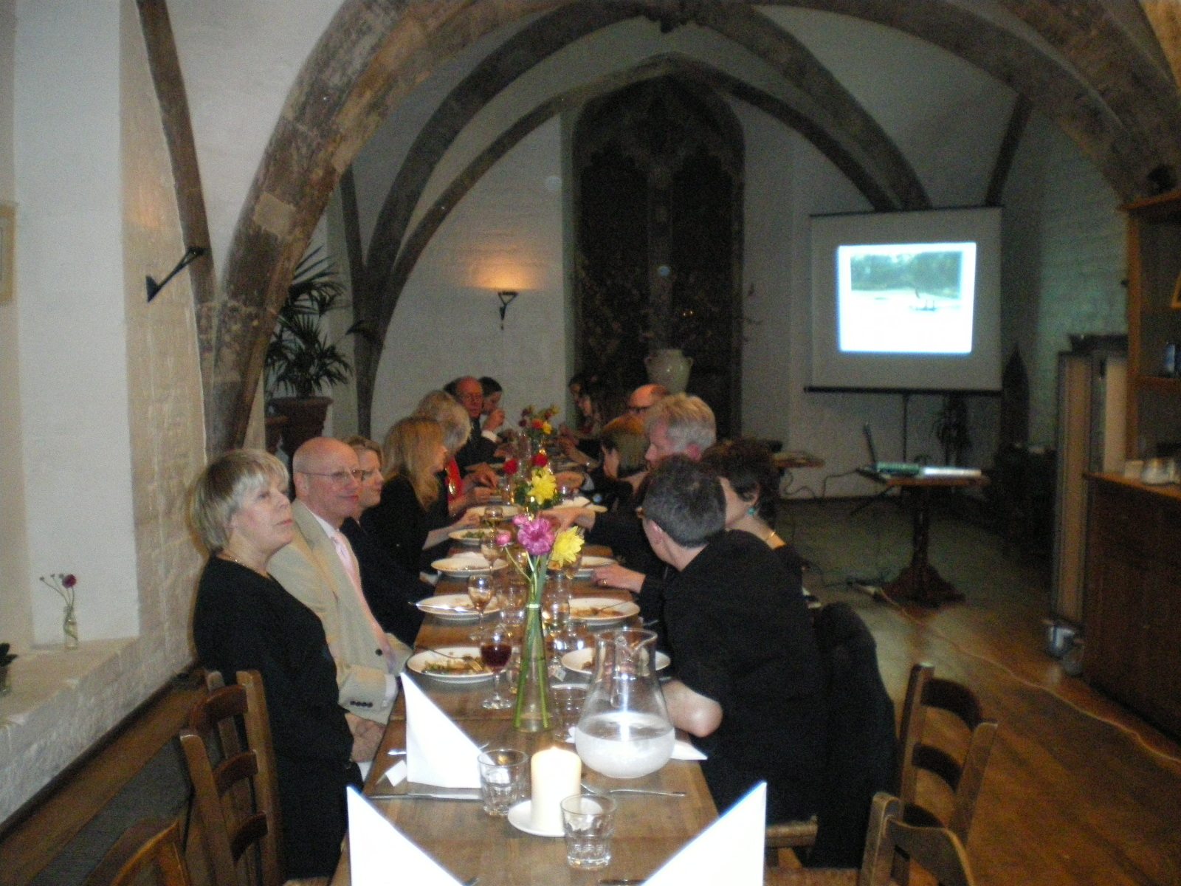
FRDAY 27TH NOVEMBER
19.00 -23.00

Gala Dinner
at the
Vaults and Gardens - oldest building in Oxford University

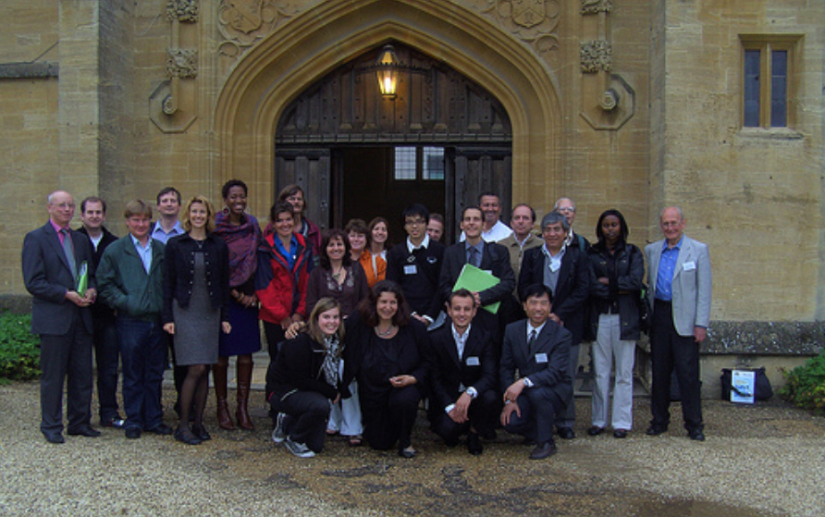
SATURDAY 28TH NOVEMBER

10.00 – 18.00
Full day conference

GREENING THE ECONOMY
at Oxford University

The Green Economics Institute

invites you to join the conference

GREENING THE ECONOMY

where an international group of specialists from the four pillars of green economics - academia, business, campaigning and policy -

will present and discuss the following subjects:

What is green economics? Progress towards a definition

As a fast moving, visionary and topical field, it is always necessary to continue to ask this fundamental question; something orthodox economics fails to do, which has lead to the distortion of its aims and its disjointedness with the real world.

So what are the latest research findings and discussions on this topic?

Green economics solutions to the current economic crisis

The current crisis provides the opportunity to align consumption with resources and rebalance towards services rather than goods. How can we act on the new opportunities the crisis provides? What are the short term and long term solutions? What is the future of financial markets? – Ethical investments?

Lower growth or de-growth

How can lower growth economies be achieved? How can de-growth and development exist together? How can we ensure the continued alleviation of poverty? How does this effect globalisation?

Climate change

What needs to happen at Copenhagen? How will businesses have to adapt? What are the solutions to food and fuel issues?

Oxford University - Saturday 28th November 2009

This day of lively, cutting edge discussions will be preceded by a

Gala Dinner

At the Vaults and Gardens, Oxford, on Friday 27th November.

This event is an occasion to socialise with like-minded people in a more informal setting, enabling you to further benefit from this gathering of forward thinkers.

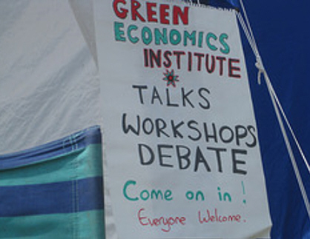
This conference is part of the world's leading conference series in green economics. Internationally-renowned composite, multidisciplinary scientists, economists, campaigners, policy makers and directors, professors, social scientists and researchers from all over the globe continue to attend this very popular series, to present their frontier research findings and to keep up to date with latest achievements and developments in this fast moving, leading, and topical field.
Green economics views the current downturn as a clash between ecology and economy and argues that the commodity instability is a symptom of the exhaustion of natural resources. The markets are correctly reflecting that and are indicating that traditional economics instruments and derivatives are no longer working, and new methods of creating a natural economics of abundance need to be urgently developed.
The world has changed and green economics is a school of economics that is comfortable with long term-ism, equity, climate issues, biodiversity costs and poverty prevention. Green economics has been waiting to take on the mantle and that time has now arrived!
We look forward to welcoming you to Oxford University, one of the most beautiful cities in the world with its famous, outstanding and atmospheric conference facilities, excellent travel connections and accommodation.

Miriam Kennet
Director, Green Economics Institute www.greeneconomics.org.uk
Editor, International Journal of Green Economics www.inderscience.com/ijge

Hosted by:
Miriam Kennet
Sophie Christopher Bowes: Ethical Business Club Oxford and specialist in Green and Permaculture planning and property
Christopher Blount: Investment Specialist
Jonathan Essex: Green Construction and Green Building
Naomi Baster (Orkney) University of Strathclyde: Award winning Economist. Green Economics Institute - Lower Growth Economics
Matthew Morgan: Green Economics as the economics of inclusion; discusses the implications of mainstream economics for the orphans with special needs in Romania where he has been working.
Nathan Hayes: Development Economist
Charles Yui Li (Hong Kong): Green Accounting Specialist

CALL FOR SPEAKERS
CALL FOR PAPERS
Requests to speak are invited, as are prospective authors to submit abstracts. This conference is designed to share latest information on green economics issues, and is also a fundraiser for the Green Economics Institute. All speakers will be required to pay the conference fees and there will be a special fundraising gala dinner at the very attractive Vaults and Gardens Restaurant - the oldest building in the University - on Friday evening.
All papers and abstracts must be submitted in word or odt format – PDF is not acceptable, and all papers must include title of paper, all authors’ email addresses, full names and affiliations. They must include a statement that the paper has not been published in English before, and is free from copyright restrictions to enable it to be published in our Conference Proceedings, and each paper must include a five-line biography of each author. Each paper must include full references and citations wherever these have been used. If any of these are missing we will not publish the paper.
If your paper is non-academic and of a business nature, please ensure it is in prose and word format for the proceedings as we cannot publish PowerPoint presentations in the Conference Proceedings.
Abstracts should be submitted to events@greeneconomicsinstitute.eu as soon as possible as speaker slots are popular and filling up fast. If you know you would like to speak but have not prepared an abstract please email me asap so that I can reserve a slot for you. Our management committee will decide on acceptance and let you know as soon as possible.
All presenters are requested to consider presenting with a Powerpoint or other visual material and also using any case studies, examples or other illustrations of their ideas and to allow at least half their session time for questions and discussion. Papers will be published for distribution to delegates at the conference in the high quality conference manual and will be formally published and can be cited as an academic publication if accepted.
All successful presenters papers will be considered for inclusion in our academic journal International Journal of Green Economics, IJGE published by Inderscience Publishers. www.inderscience.com/ijge – the first green academic journal in the world.
Please send all PowerPoint presentations at the conference at least 7 calendar days prior to the event to ensure we can put them on the laptops for presentation.
Please email us on events@greeneconomicsinstitute.eu as soon as possible to let us know.
2009 BOOKING
Details for Registration

Conference attendance fee £90 for the day of 28th November 2009.
Optional additions:
Fundraising gala dinner supporting the Green Economics Institute
at the Vaults and Gardens
Friday night
£80 per person
£100 if booked after 20th October 2009
10% reduction for members and 10% reduction for speakers:
Saturday evening dinner -
Oxford University Club
£20.00 per person
Advertising your business, department or company in the conference proceedings:
£500 per page
Payment now accepted online - please email to advise us of your requirements and requests to participate and to reserve your place.
Special Membership Offer
If booking for the conference, a reduced membership fee will be available for £40 for 2010 and remainder 2009 (if requested at time of booking for the conference)
Publications
All paid up delegates and attendees at the gala dinner and the conference will receive a copy of the Conference Proceedings on arrival at the conference.
All speakers are required to pay the relevant registration fee.
Full Proceedings Papers from speakers to be sent to:
greeneconomicsevents@yahoo.co.uk

Further information from
greeneconomicsinstitute@yahoo.com
www.greeneconomics.org.uk


